UI Layout Apr.14

Hao YAN

Main menu:

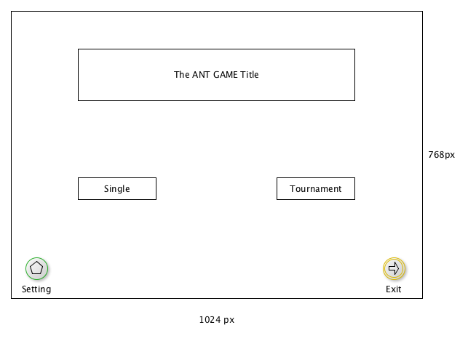

Two player model: single and Tournament

Allow full screen or enlarge.

Background could be an ant wallpaper or anything else, even a short VT

|  |  |
| --- | --- |
| Button | Result |
| Close the application(top right corner) | Close the application |
| Single | Transit to the Single mode page |
| Tournament | Transit to the Tournament mode page |
| Setting | Set the screen size or other appearances. |
| Exit | Close the application in full screen. |

Single Mode

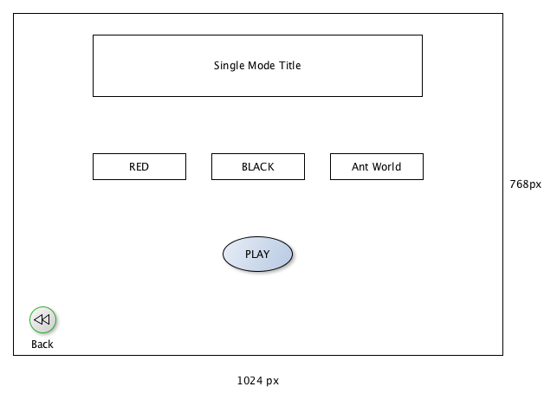

|  |  |
| --- | --- |
| Button Name | Result |
| Close the application(top right corner) | Close the application |
| Red | Red Ant Brain upload window |
| Black | Black Ant Brain upload window |
| Ant World | Ant World upload window |
| PLAY | Start to play when the ant brain is uploaded, otherwise remains grey and cannot be clicked. |
| Back | Return to the main menu |

Upload window

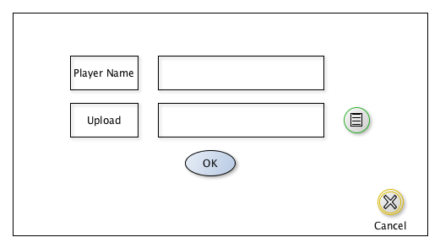

|  |  |
| --- | --- |
| Enter the player name | Input player name to the name filed in the program |
| OK | Since input the valid player name and. ant file. Otherwise remain grey and cannot be clicked. |
| Upload | Open the file selection window. If choose the invalid file would not accept and send error message. |
| Cancel | Return the mode menu. |

Tournament Mode

// empty temp